Benjamin Cagle, Jeshua Corgan, Miguel Ramirez, Will Hamilton

ENGR 114 : Spring 2019

June 11, 2019

Always Rhinos

Project Statement

Our group was tasked with using Python to interact with a microcontroller, of our choosing, to dynamically collect sensor data or control a relay and post the data or relay state on ThingSpeak (an IoT cloud server). We have chosen to use a Raspberry Pi connected to a water level sensor. The Raspberry Pi will collect data from the sensor and send an email when the water level gets too low. The email will be sent to an account on Thingspeak.com. The operator will use this email as an indicator to add water to the tank.

Hardware Setup

Bill of Materials:

* Raspberry Pi 3B+
* Water level sensor from Kuman (K5 kit)
* Microchip MCP3008-I/P ADC
* Breadboard MB-102 (Ever-Muse)
* Connectors (Male to Male) (Female to Male)

-See Hardware Setup template for chart specifics Hardware Schematic.

- See Hardware setup template for details. Follow similar format to the Sparkfun inventor’s guides.

- Image of hardware all connected. Multiple images can be included.

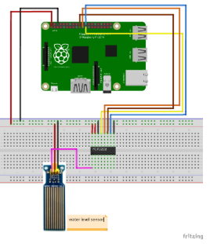

Kookye.com. (2017). *Design a water level detector through a raspberry pi board and water level sensor – kookye.com*. [online] Available at: http://kookye.com/2017/06/01/%E5%9F%BA%E4%BA%8E%E6%A0%91%E8%8E%93%E6%B4%BE%E7%9A%84%E6%B0%B4%E4%BD%8D%E6%BA%A2%E5%87%BA%E6%A3%80%E6%B5%8B%E5%99%A8/ [Accessed 30 May 2019].

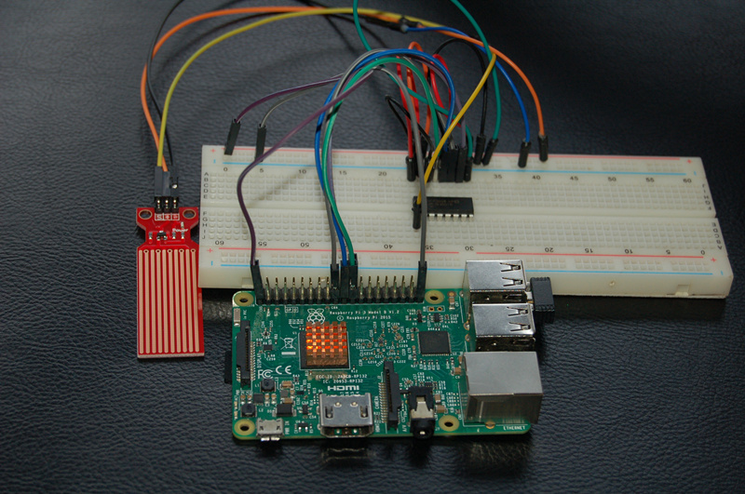

Code

Python Code (from a .py-file) - format this nicely. Ensure the code contains a header, is sectioned in a logical way is well commented and documented. Consider about one line of comments for each line of code. The Python code should be copied and pasted, not imported as an image which cannot be modified.

Arduino Code or MicroPython code (from a .ino-file or .py-file) - format this as nicely as you can. Ensure it contains a header and is well commented and documented. About one line of comments for each line of code. The code should be copied and pasted, not imported as an image which cannot be modified.

Results

Include a picture or a plot. Must have something visual in this section.

Future Work

What could another group of students do to build on this project? Any resources this group could use to build this future work?

License

Can be MIT licenses or BSD license. Include if you want to others to acknowledge where the work came from.

Kookye.com. (2017). *Design a water level detector through a raspberry pi board and water level sensor – kookye.com*. [online] Available at: http://kookye.com/2017/06/01/%E5%9F%BA%E4%BA%8E%E6%A0%91%E8%8E%93%E6%B4%BE%E7%9A%84%E6%B0%B4%E4%BD%8D%E6%BA%A2%E5%87%BA%E6%A3%80%E6%B5%8B%E5%99%A8/ [Accessed 30 May 2019].